**EMS Proposal**

**Team Members:**

· **Nadezhda Mokhireva**

· **Viacheslav Nepomniashchyi**

· **Sergio Lombana**

**Coordinator: Maziar Masoudi**

Here is presented the proposal for the Event Management System (EMS) for George Brown College. The purpose of the project is to deliver a convenient way to sign up for events that take place at college. Our primary focus is the ease of use and reliability, but the team also keeps in mind such aspects as room for expanding and adding new features.

In order to create a dynamic application that would work across operating systems, PHP, Laravel and MySQL database are chosen as development tools. Prior to designing the UML diagram, the team members are to create a GitHub repository under which the project will be stored. The first released version of the EMS should include the following functionality:

1. View all upcoming events

2. Filter the view by subject/date

3. See event details (location, date & time, description, list of participants) upon clicking on its title in the view list

4. Sign up for the event (provide name, contact email and choose dates if there are several)

5. Access FAQs what is this for?

6. Write and read messages in the event discussion

There also should be an option to create an account (user must be a current George Brown College student) to provide additional privileges: (for now maybe only a member with a special role can create an event[not admin])

1. Add an event

Event detail location, time, max number of participants (with unlimited option)

2. Generate report with the number of people who signed up for different dates of an event (as a graph)

3. Attach documents to the event (for example, handout materials or summary of the content)

This document is only a general description of the project. The developers’ team will be glad to provide any additional information.

**UML (Classes and relationships only, no states and behaviours)**

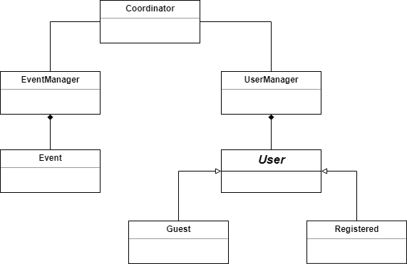

**MOCKUPS.**

**Profile mockup page:**

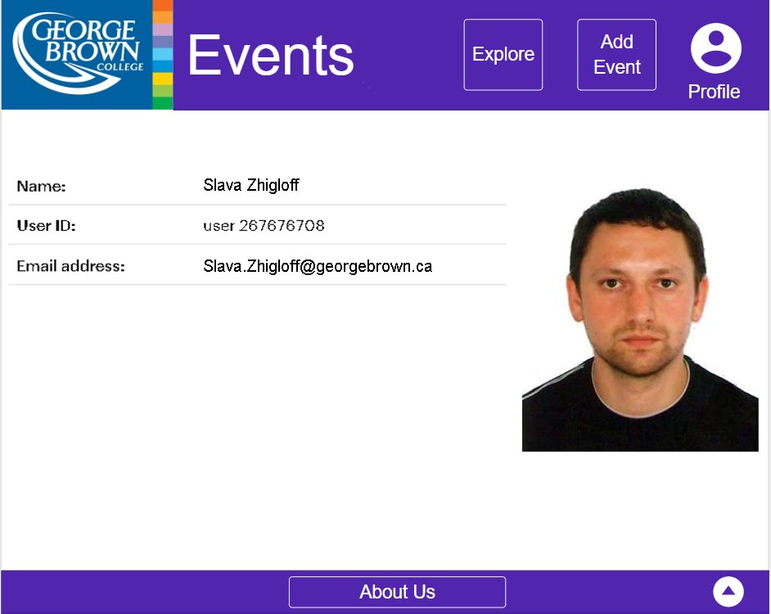

**Upcoming Events mockup page:**

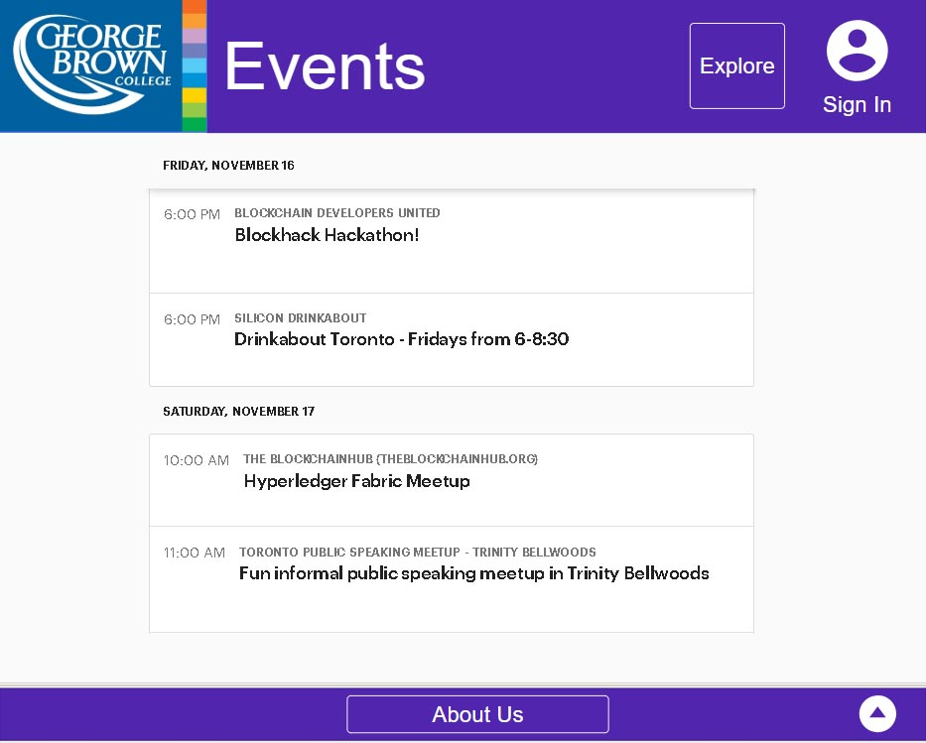

**Create event:**

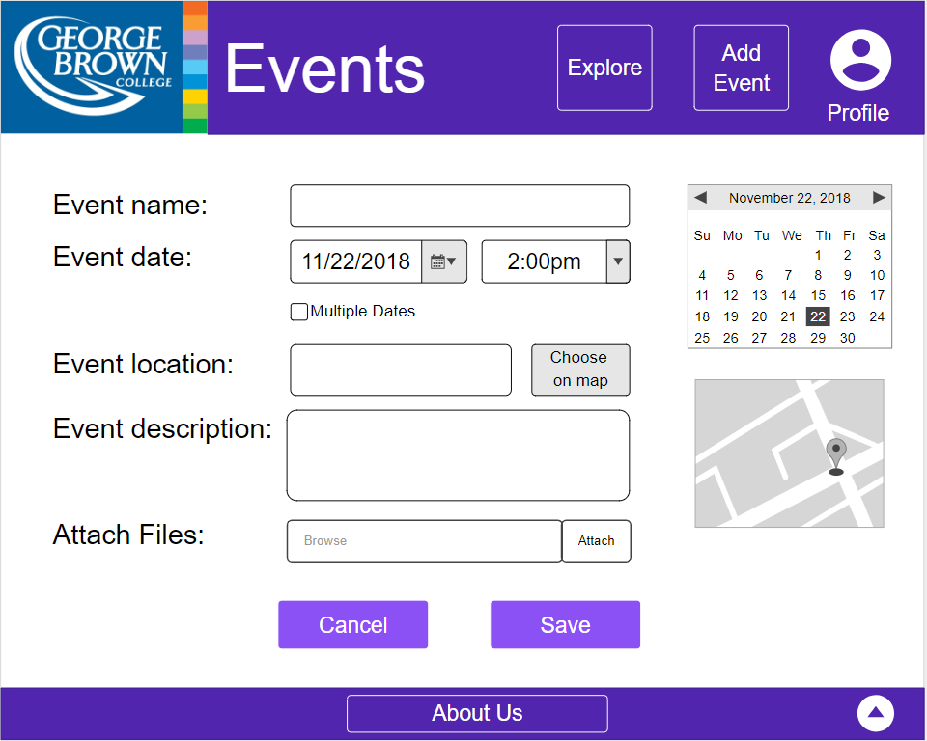

**Modify event**

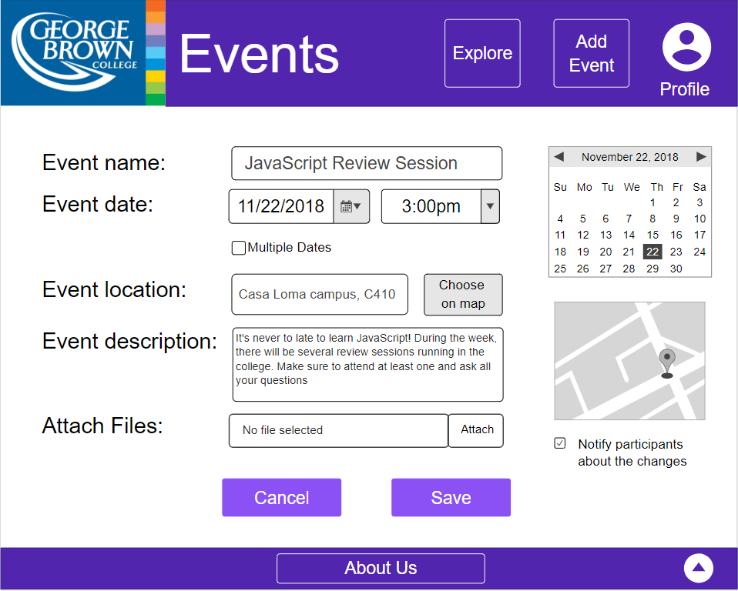

**Login Page**

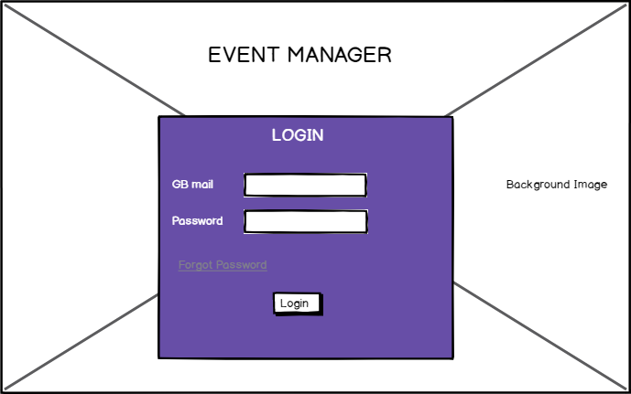

**Sign Up Page**

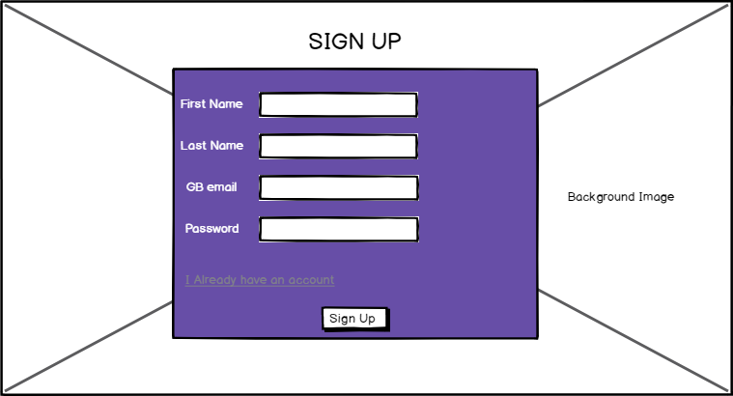

**Event Detail for student**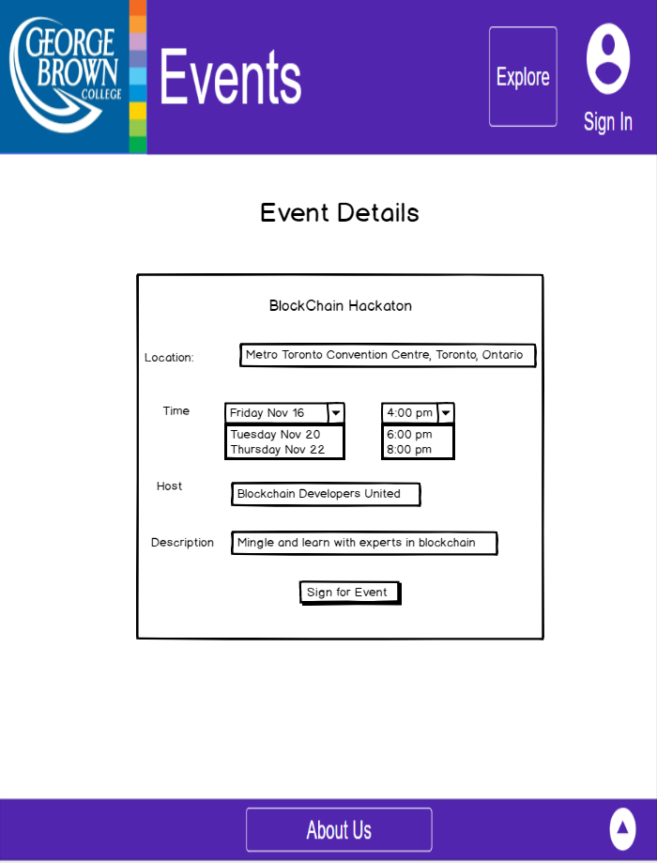

**Event Details for Event Manager**

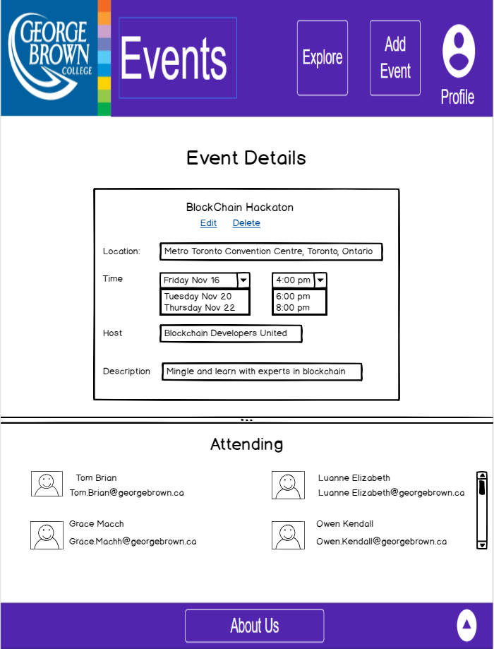

**UPDATE AS FOR NOVEMBER 28**

**ACCESS;**

Guest (unregistered user) will be able to

* see all events($eventId, *$eventStatus*)
* see event details with number of attendees(Event $eventList[], $eventId, $eventName, $eventDate*[]*,$eventOwner, $eventLocation, $eventTime[], $eventDesc )
* sign up for this event()
* download files that are attached to an event(*$attchFile*)
* create an account(User $userList[], $fName, $lName, $uEmail, $userId, $userPass)

Registered user will be able to do all the same plus the following:

* modify event()
* add an event()
* delete event()
* see and download event report attached to event details()
* import a file()
* see created and attended events()

**REQUIRED METHODS:**

Coordinator - coord

* generateReport() -
* exportReport() -
* signUpForEvent() -
* signUpConfirm() // email notification that they signed up -

UserManager - uMan

* addUser() //register, create an account - Nadia
* viewUserInfo() - Nadia

EventManager - eMan

* addEvent() //for registered only - Sergio
* importFile() - Slava
* modifyEvent() - Sergio
* listEvents() - Sergio